Writing blogs
Ian Ki Hoon Suh
Profess. Myers.
Eng202D

Adoption of New Technology
The participation of the new technology to the monetary growth has been comprehended if and when the new tech is used and subtle. A comprehension of the factors that affect the adoption of new technology is significant both for the economists that are studying the elements of growth and for the producers and creators of such tech. Diffusion comes up from a series of individualistic choices to start using technology.
Unlike the new technology invention, the diffusion of technology is observed to be a consistent but slow protocol. Diffusion is observed to be aggregate or cumulative outcome of individual controls which way the incremental advantages of espousing new tech in contradiction of the costs of change and by limited information.

Image source: https://www.forbes.com/sites/hankprybylski/2019/02/08/why-most-companies-arent-ready-to-adopt-advanced-technology-at-scale/#31b7f4fa316b
The most significant part about adopting new technology are the flow benefits that are recognized in the entire life if the acquired modernization (Cotrino, Ifedi, Reynolds & Donthu, 2019). The adoption of new technology has been impacted by the insurance surrounding and environmental regulations. The market structure of the phase providing the new innovation has impact on adoption, for instance, mobile telephony.
Poultry Pumpkin Agri-Business
Poultry farming is now taking over animal husbandry in the agriculture industry. Poultry has more benefits than you can imagine and they have a high demand in the market. Poultry is an umbrella name that covers a variety of birds kept for different reasons by the farmer. On the list are ducks, turkey, guinea pigs, pigeons, and chicken. There is a range of varieties of chicken breeds kept by farmers.
Some are kept in zero-grazing style, where they are provided with food, water, and other necessary supplies. Others are kept in free-range style, where they hustle for their foods and go about picking up palatable feeds around like grains, vegetation, earthworms, and insects (Achiri & Bongkisheri, 2018). These birds provide the farmer with both meat and eggs. Poultry farming is cheap and easy to practice as compared to any other livestock farming as these birds have easily fed on the available feeds around the compound.
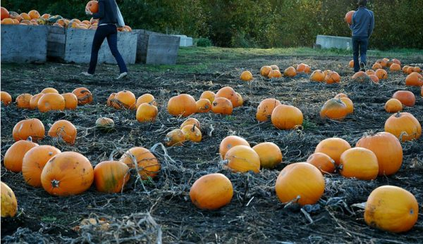
Image Source: https://www.hobbyfarms.com/start-a-pumpkin-patch/
Most chicken farmers have initiated the trend to feed their chicken on the pumpkin for the benefits of the present vitamins and antioxidants needed by the chicken. According to other chicken farmers, they resulted to feed their chicken on pumpkin because they believe pumpkins to be a good natural wormer for the birds. This is not yet proved scientifically. If might cross you mind with a question on how to feed my chickens pumpkin wondering whether to cook or give them raw.
Internet Protocols
Every device that connects to the internet is assigned numerical label that identifies it and locate its network address to facilitate effective communication. This numerical label is referred to as the internet protocol IP (McMillan & Zuck, 2019). Due to demand growth in internet, a depletion of version 4 of internet protocol, commonly referred to as IPv4, that uses 32 bit was experienced. In 1998 a standardization of an upgraded version of IPv6 that uses 128 bit was then developed and has been in use since the mid-2000s.
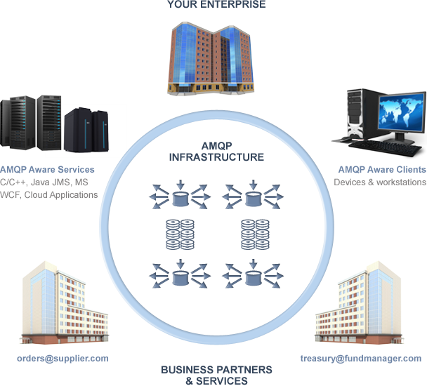
Image source: https://www.amqp.org/about/what
Therefore, you should be able to use the available Country Ip Ranges Database provided by your ISP to make your evaluation on contracting them. These include:
- Local content; you should be able to provide your service in the local and international languages. The ISP in question needs to have a vivid knowledge of the areas dialects, culture and state laws and advice you otherwise. Be able to provide with familiar words and places to the locals. These factors will indeed help in content delivery and advertisement coverage without violation certain norms.
- Market analysis; there are many hidden opportunities that you might need to know about. Through their IP Geo-location tools, you should be able to enjoy these among other benefit so as to improve your market stand in a given area.
- Security; most ISP don’t guarantee you security from hazardous factors like cyber-crimes. Get an assurance package on your protection from online fraudsters and theft.

References
Achiri, D. T., & Bongkisheri, V. (2018). Influence of Mineral Fertilizer on Vegetative Parameters of Fluted Pumpkins (Telfairia occidentalis Cucurbitaceae) in Buea, Cameroon. International Journal of Plant and Soil Science, 25 (5), 1-7.
Cotrino, F., Ifedi, C., Reynolds, S., & Donthu, N. (2019). Exploratory Study of Factors That Lead to Technology Adoption in Small Businesses. Available at SSRN 3454113.
McMillan, K. L., & Zuck, L. D. (2019, September). Compositional Testing of Internet Protocols. In 2019 IEEE Cybersecurity Development (SecDev) (pp. 161-174). IEEE.

